Subgroup H

H.1 — [S01H1] Extract hashtags and mentions
Scenario (e-commerce):
Context:
Moderation in the e-commerce app needs hashtag and mention extraction.

Your Task:
Use regex to extract @mentions and #hashtags (case-insensitive) and return lowercase lists.

Data & Edge Cases:
Punctuation around tags should be ignored.

AI Assistance Expectation:
Ask AI for a robust regex and tests covering multiple tags.

Constraints & Notes:
Return mentions and hashtags lists; lowercase.
Sample Input
Hello @alice check #AI and #Python with @Bob
Sample Output
mentions=['alice','bob'], hashtags=['ai','python']
Acceptance Criteria: Lowercased; ignores punctuation
Prompt:- Write a Python function using regex to extract @mentions and #hashtags from text.
The function should return two lowercase lists (mentions, hashtags), ignoring punctuation.
Add test cases covering multiple tags, mixed case, duplicates, and no tags.
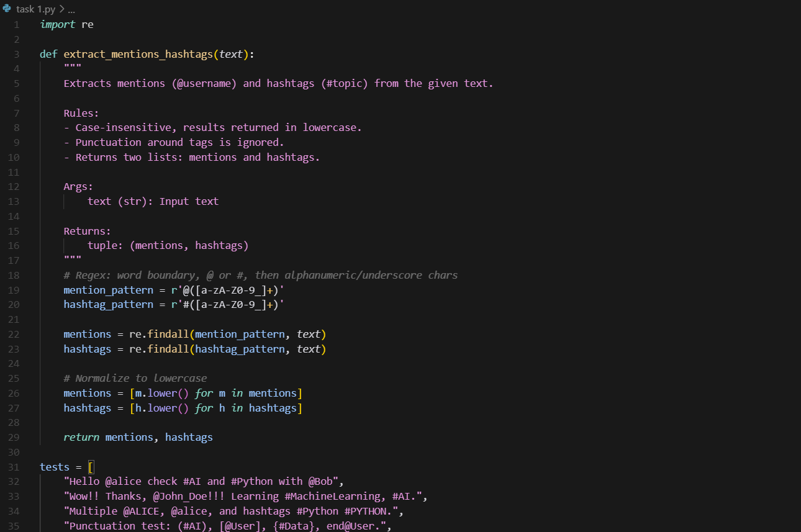
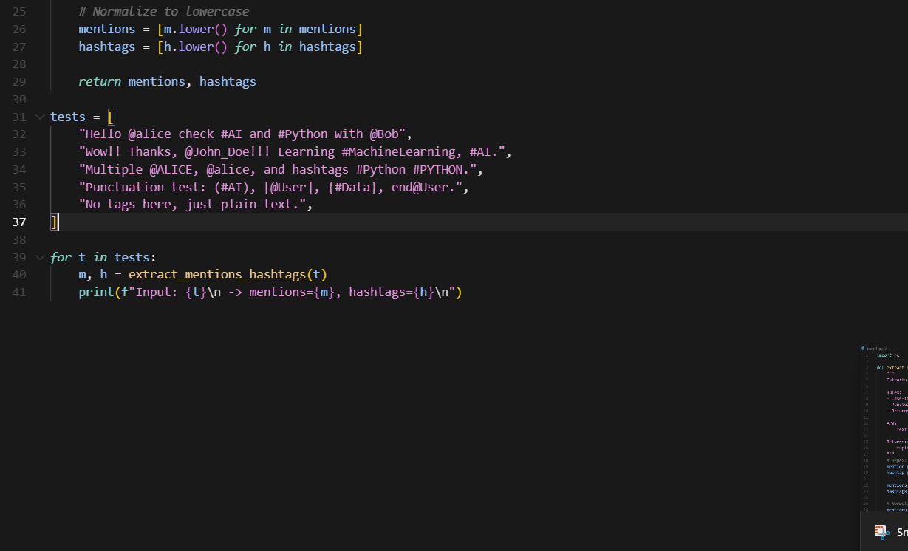
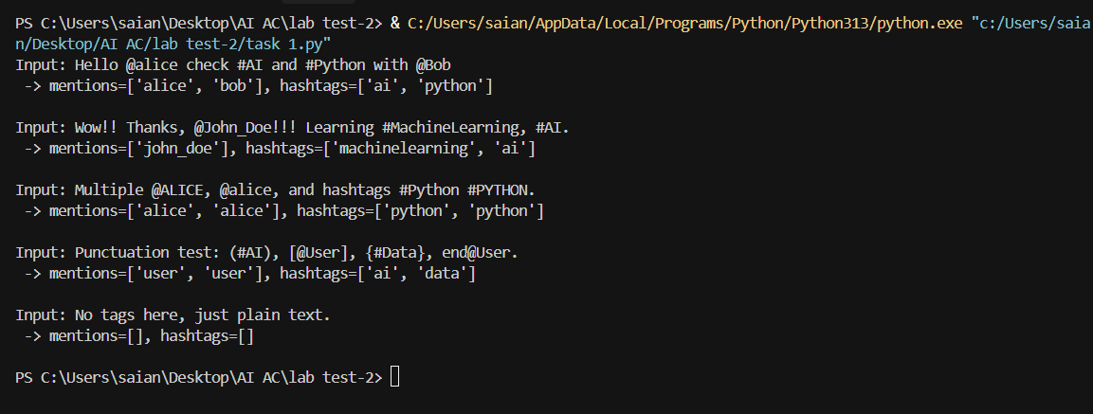

H.2 — [S01H2] Shortest path on weighted graph (Dijkstra)
Scenario (e-commerce):
Context:
Routing decisions in the e-commerce graph need shortest paths for small, weighted graphs.

Your Task:
Implement Dijkstra from a source node 'A' to all nodes using a priority queue.

Data & Edge Cases:
Use adjacency dict with positive weights.

AI Assistance Expectation:
Prompt AI to outline the algorithm steps and edge relaxation pattern.

Constraints & Notes:
Return dict of distances with 0 for source.
Sample Input
{'A':{'B':1,'C':4},'B':{'C':2,'D':5},'C':{'D':1},'D':{}}
Sample Output
{'A':0,'B':1,'C':3,'D':4}
Acceptance Criteria: Correct distances; stable for positive weights
Prompt:- Write a Python function to implement Dijkstra’s algorithm using a priority queue.
The function should take an adjacency dictionary with positive weights and a source node, and return shortest path distances from the source to all nodes.
Include a sample test graph and print the output.




